To explore the long-term development of violence in Western Europe, the homicide dataset is visualized using a line graph. The year is placed on the x-axis and the homicide rate per 100,000 people on the y-axis. Each country is represented by a different color in order to compare trends across regions.
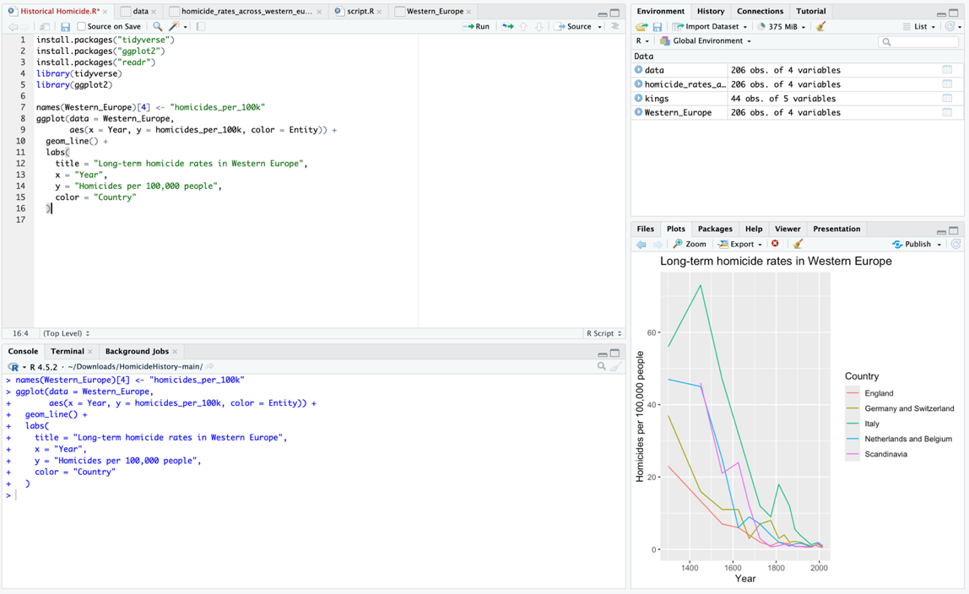
ggplot(data = Western_Europe,
aes(x = Year, y = homicides_per_100k, color = Entity)) +
geom_line() +
labs(
title = "Long-term homicide rates in Western Europe",
x = "Year",
y = "Homicides per 100,000 people",
color = "Country"
)
The graph shows a clear long-term decline in homicide rates across Western Europe. During the medieval period, homicide rates were significantly higher than today. Over the centuries the rates gradually decreased, especially after the early modern period. By the nineteenth and twentieth centuries the rates were considerably lower across all regions.

While the first graph shows the general trend, it can be difficult to distinguish each country’s development when they are displayed in a single visualization. To solve this, the data are separated into individual charts using the facet_wrap() function.
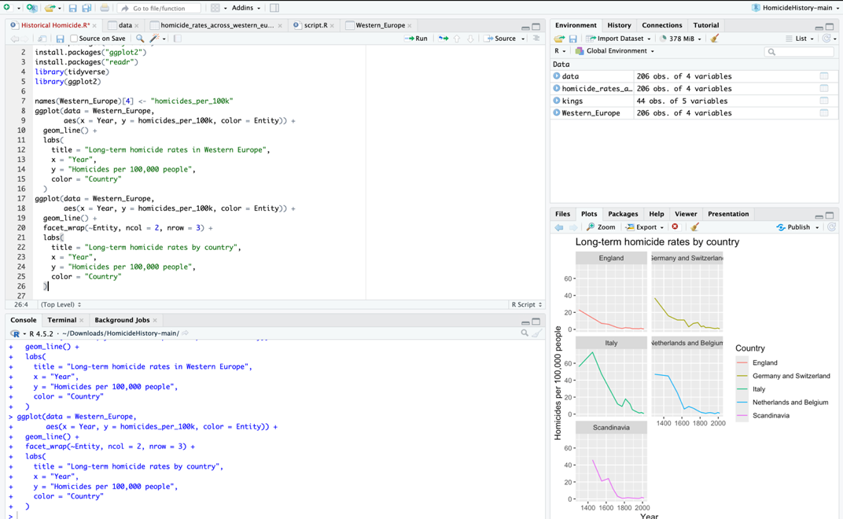
ggplot(data = Western_Europe,
aes(x = Year, y = homicides_per_100k, color = Entity)) +
geom_line() +
facet_wrap(~Entity, ncol = 2, nrow = 3) +
labs(
title = "Long-term homicide rates by country",
x = "Year",
y = "Homicides per 100,000 people",
color = "Country"
)
The faceted visualization allows us to observe each country’s trend separately. Although the exact levels vary slightly between regions, all countries demonstrate a similar long-term decline in homicide rates. England shows a particularly strong decrease from very high levels in the medieval period to very low levels in the modern era.

The assignment also asks us to compare the homicide trends with the duration of reign among Danish rulers. To visualize this, a new variable called midyear is created. This variable represents the midpoint of each monarch’s reign and is calculated using the start year and end year.
kings <- kings %>%
mutate(midyear = endyear - (endyear - startyear)/2)
The relationship between time and reign duration is then visualized using a smoothed trend line.
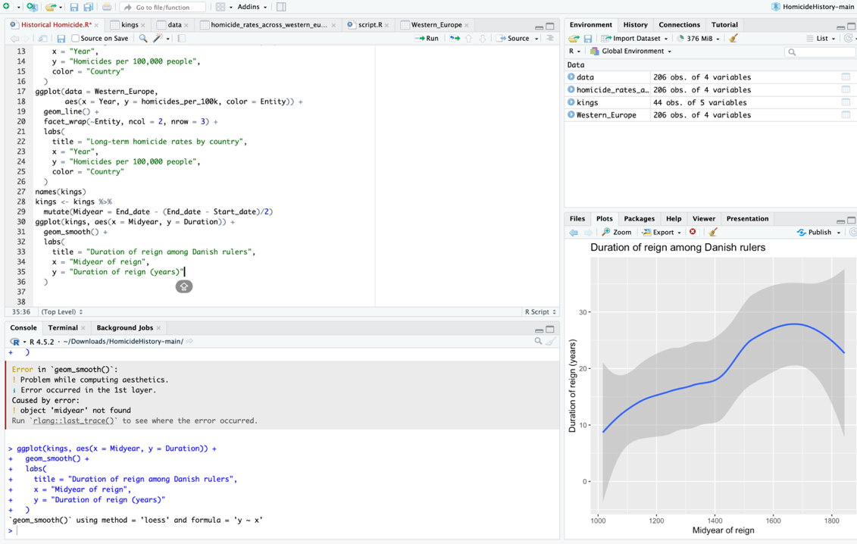
ggplot(kings, aes(x = midyear, y = duration)) +
geom_smooth() +
labs(
title = "Duration of reign among Danish rulers",
x = "Midyear of reign",
y = "Duration of reign (years)"
)
This graph shows the variation in the duration of Danish rulers’ reigns over time. Compared to the homicide trends, the pattern is less consistent and does not show the same long-term decline. Instead, reign duration fluctuates depending on political stability, succession patterns and historical events.

The final plot presents the homicide trends by country with an improved layout where the legend is placed below the visualization.
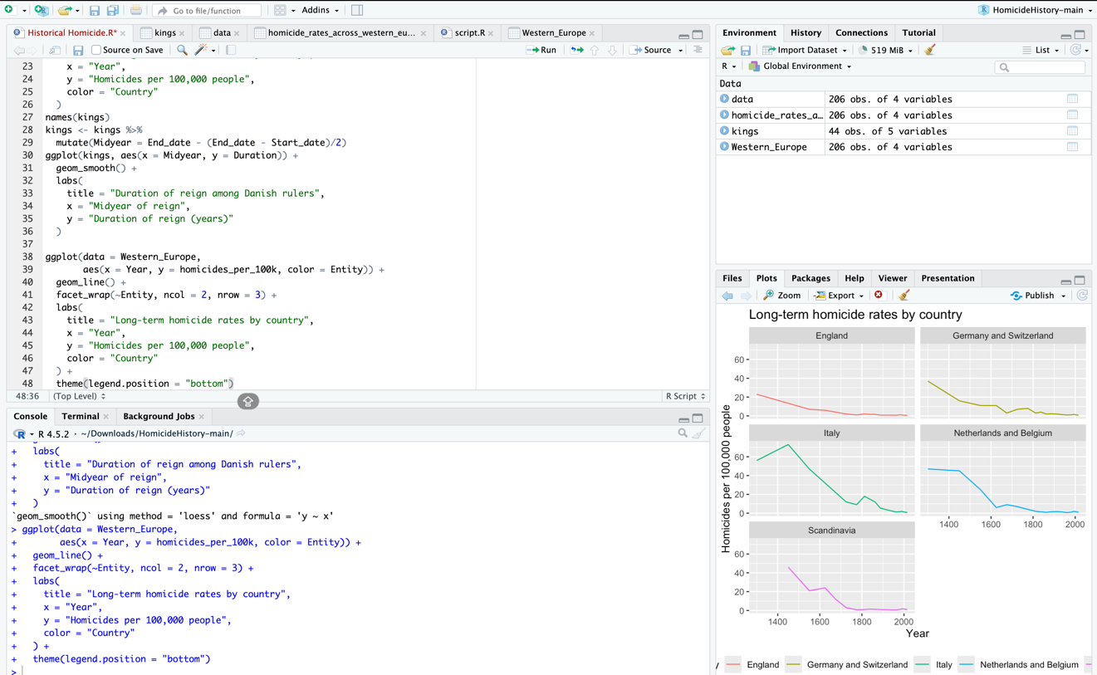
ggplot(data = Western_Europe,
aes(x = Year, y = homicides_per_100k, color = Entity)) +
geom_line() +
facet_wrap(~Entity, ncol = 2, nrow = 3) +
labs(
title = "Long-term homicide rates by country",
x = "Year",
y = "Homicides per 100,000 people",
color = "Country"
) +
theme(legend.position = "bottom")

Are we more civilized today?
The visualizations show a clear long-term decline in homicide rates across Western Europe. In the medieval period, homicide rates were much higher than today, often exceeding 20 homicides per 100,000 people. Over the centuries these rates gradually declined and reached very low levels in the modern period.
This trend suggests that societies have become less violent in everyday interpersonal interactions. Scholars have linked this development to the formation of stronger states, more effective legal systems and changes in social norms. Steven Pinker discusses this idea in The Better Angels of Our Nature, arguing that the development of institutions and the rule of law has reduced the need for individuals to resolve conflicts through violence.
However, lower homicide rates do not necessarily mean that societies are completely free from violence. Violence still occurs in different forms such as war, political conflict and structural inequality. Nevertheless, the long-term decline in homicide rates suggests that interpersonal violence has decreased significantly, indicating an important shift in social behaviour over time.

